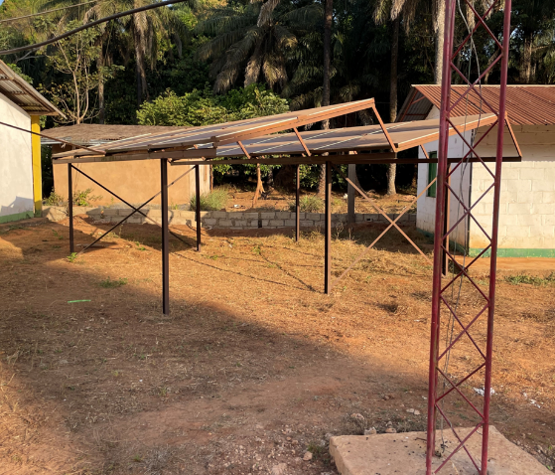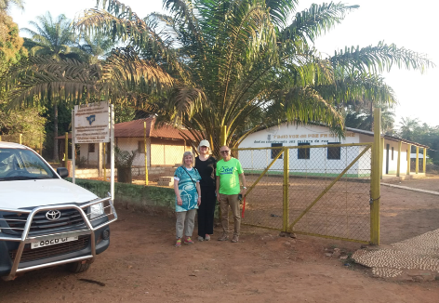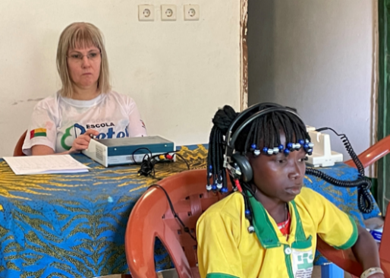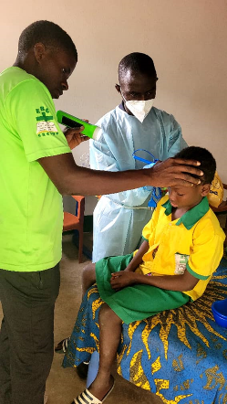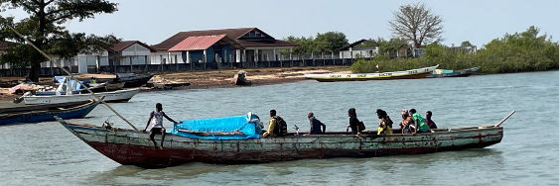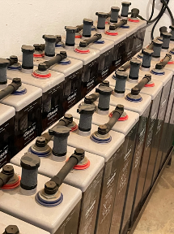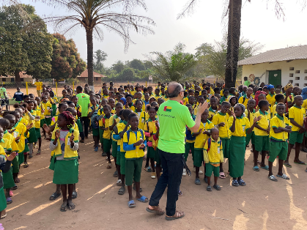SUMMERLETTER 2023-07-24 from   
At the beginning of the year, Ulf Fransson, Cecilia Gerhardsson and Carina Nilsson travelled to Cacine Erikshjälpen had donated equipment for otoscopy and hearing measurement. Carina is an audiologist Carina examines Ismael, rinses his ears clean  
and examined 175 students in years 1-3. The week after the examination, Valberto arranged for a nurse (a former student) to flush out the 30 wax plugs that Carina had noted.  
Artur, a volunteer from Brazil, was at the school for six months. He handled IT and mathematics teaching. At our annual meeting in Möcklamo mission house, we decided to invest in a water well, toilet construction and a smaller headmaster's room.   
A librarian support was decided on for 5 years Carina, Cecilia and Valberto in front of the radio station and likewise school fees on an ongoing basis. At the radio station, the solar cells and batteries are already in place, which the association has paid for. Valberto travelled to Brazil during April-June, to visit his homeland. Artur was there the whole time and also when The new well at the school  
Valberto returned. Graduation must be held on either day.   
The solar cells and batteries are in place

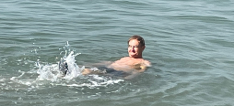 Bethel School The port of Cacine.   
During the spring (dry season) the well at the school has already been installed. The school has 730 students. The school fees for Escola Betel for the lock year 2023/24 are still SEK 400 (40 Euros), some of you have already paid Ulf takes a "cooling" bath  
 and there is still time until July 15. It is a large and important support for school activities. everyone's delight   
The association and principal Valberto once again express their big THANKS for all paid school fees and other gifts given during 2023  
We have participated in the big flea market at Stinsen Arena and in the Pilabopark to sell for the benefit of Escola Betel. On 27/8 and 9/9, the flea markets continue. We also have a Guinea-Bissau evening in Kulla chapel on Friday, October 6 at 19.00 with slide show, African music, sale, serving. More info later!   
**The board of the Cacine association wishes you a happy summer!** Website: [http: //cacine.se](http://cacine.se)

DEVELOPMENT THROUGH **Promoting sustainable development**EDUCATION GUINEA-BISSAU **through** **education**